CAFÉ ETOILE SALES

PROBLEM STATEMENTS

KPI REQUIREMENTS:

- Total Sales Analysis
  - Calculate the total sales for each respective month.
  - Determine the month-on-month increase or decrease in sales.
  - Calculate the difference in sales between the selected month and the previous month.
- Total Orders Analysis
  - Calculate the total number of orders for each respective month.
  - Determine the month-on-month increase or decrease in the number of orders.
  - Calculate the difference in the number of orders between the selected month and the previous month.
- Total Quantity Sold Analysis
  - Calculate the total quantity sold for each respective month.
  - Determine the month-on-month increase or decrease in the total quantity sold.
  - Calculate the difference in the total quantity sold between the selected month and the previous month.

CHARTS REQUIREMENTS:

- Calendar Heat Map:
  - Implement a calendar heat map that dynamically adjusts based on the selected month from a slicer.
  - Each day on the calendar will be color-coded to represent sales volume, with darker shades indicating higher sales.
- Sales Analysis by Weekdays and Weekends:
  - Segment sales data into weekdays and weekends to analyze performance variations.
  - Provide insights into whether sales patterns differ significantly between weekdays and weekends.
- Sales Analysis by Store Location:
  - Visualize sales data by different store locations.
  - Include month-over-month (MoM) difference metrics based on the selected month in the slicer.
  - Highlight MoM sales increase or decrease for each store location to identify trends.

      - SQL QUERIES on these Problem Statements
- Created the database and selected it for use.
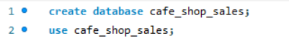
- Check the contents of the table


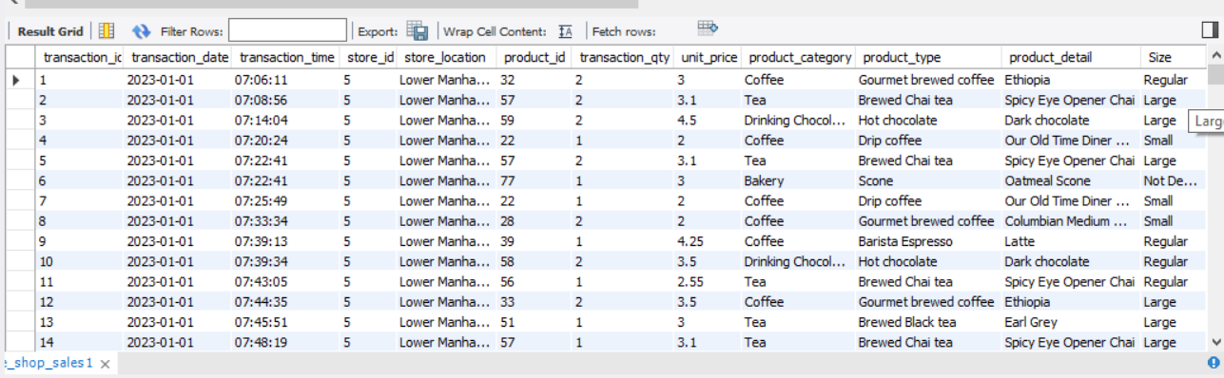

- Let’s see all the data type of the table columns.
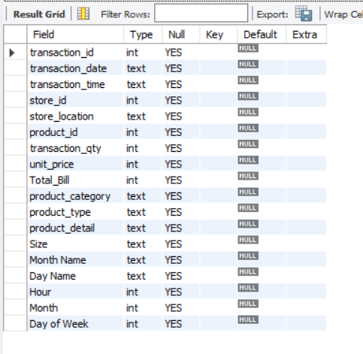
- CONVERT THE DATE AND TIME COLUMNS INTO PROPER FORMAT:
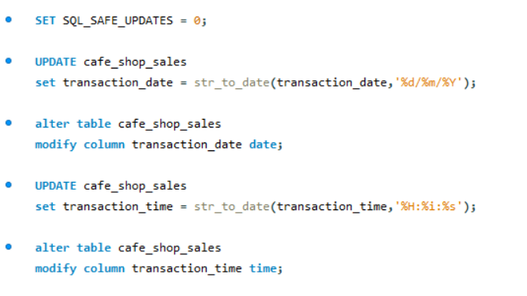
- And now the date and time columns are in appropriate format:

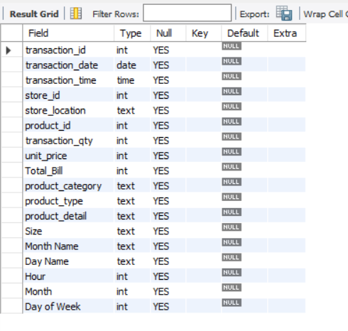

- TOTAL SALES ANALYSIS:
  - Calculate the total sales for each respective month.
  - Determine the month-on-month increase or decrease in sales.
  - Calculate the difference in sales between the selected month and the previous month.
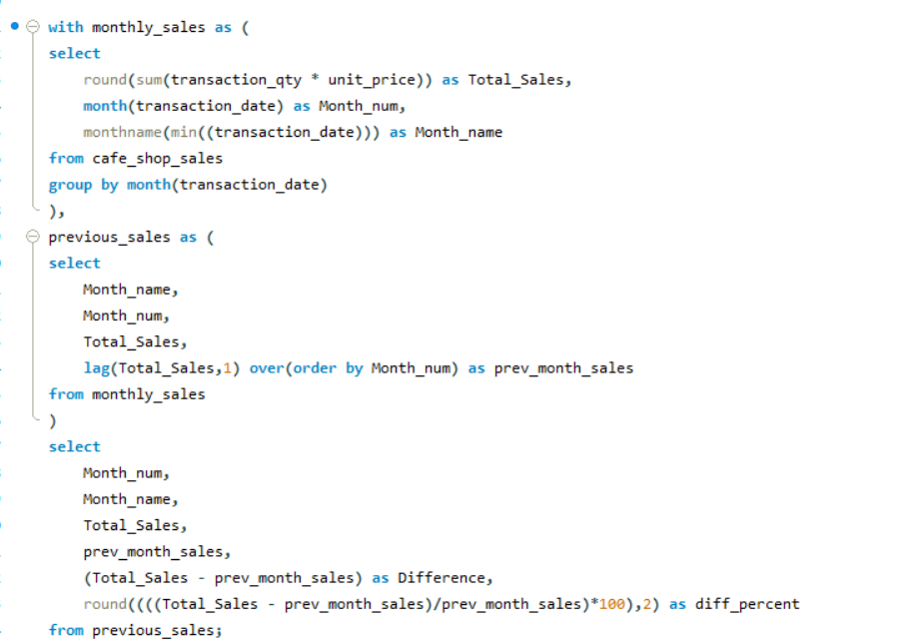

We have the output here for all the SALES analysis’ problem statement:
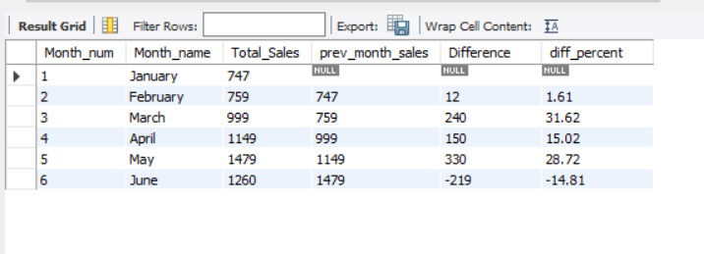
- TOTAL ORDER ANALYSIS
  - Calculate the total number of orders for each respective month.
  - Determine the month-on-month increase or decrease in the number of orders.
  - Calculate the difference in the number of orders between the selected month and the previous month.
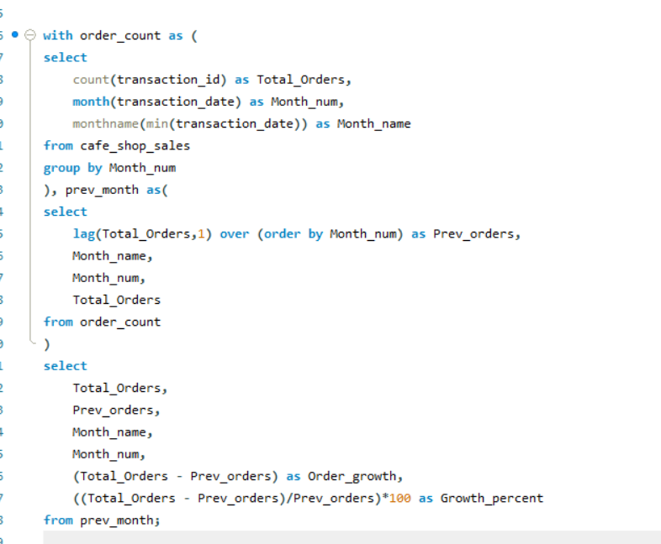
We have the output here for all the ORDER analysis’ problem statement:
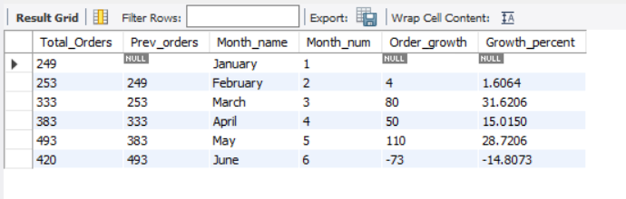
- Total Quantity Sold Analysis
  - Calculate the total quantity sold for each respective month.
  - Determine the month-on-month increase or decrease in the total quantity sold.
  - Calculate the difference in the total quantity sold between the selected month and the previous month.
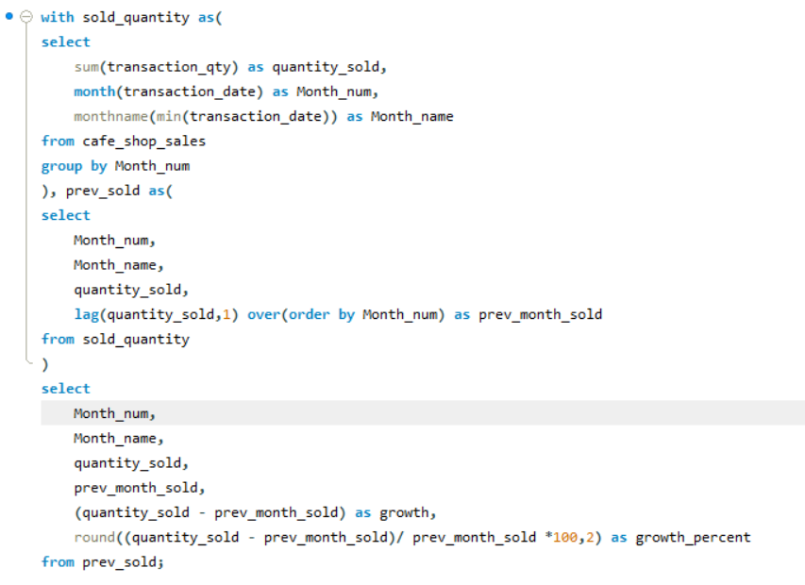
We have the output here for all the QUANTITY SOLD analysis’ problem statement:
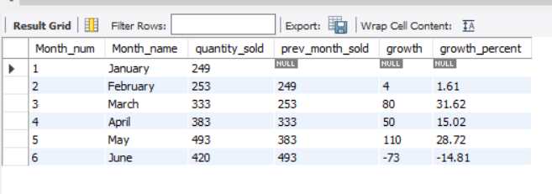

- Individual date sales, orders and quantity sold:
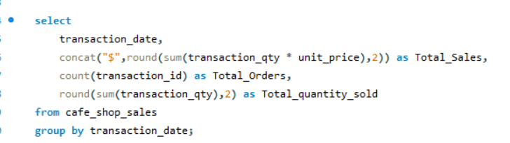

- Here we only see the output from all the months :
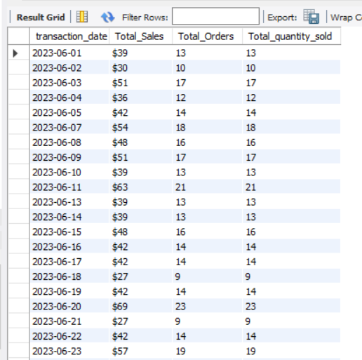

- If we need any specific month’s data then we can use “WHERE” clause to retrieve the data:
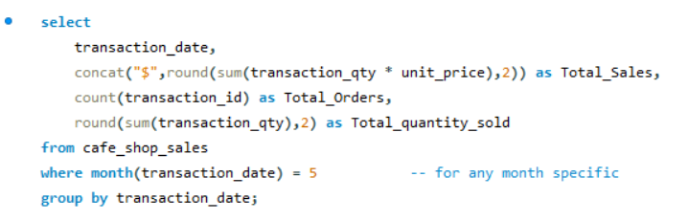

- Here we can see only the result for the month “May”:

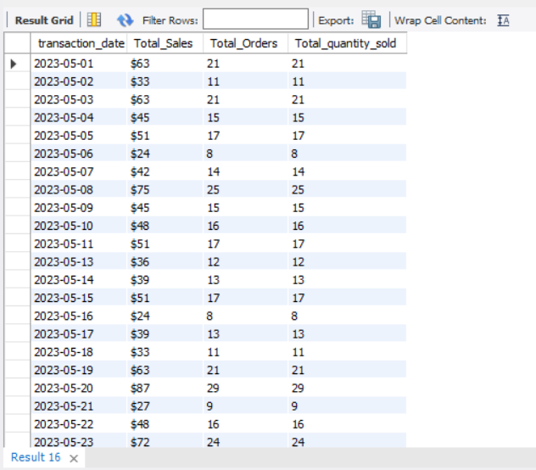
- WEEKDAY v/s WEEKEND : SALES, ORDERS AND QUANTITY SOLD
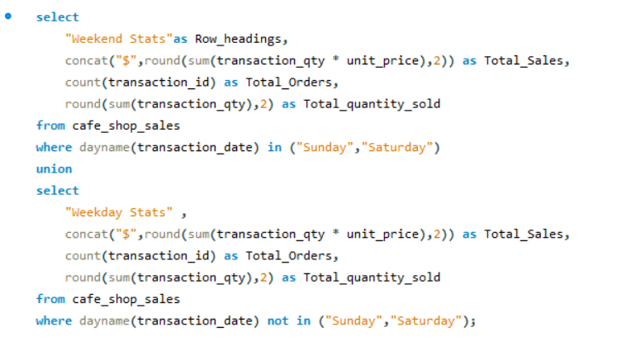
- We have the below results for the query:
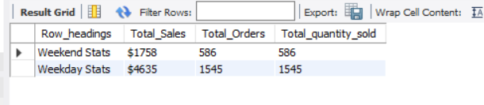
- Is there any insights we can derive from average sales in weekdays and weekends?
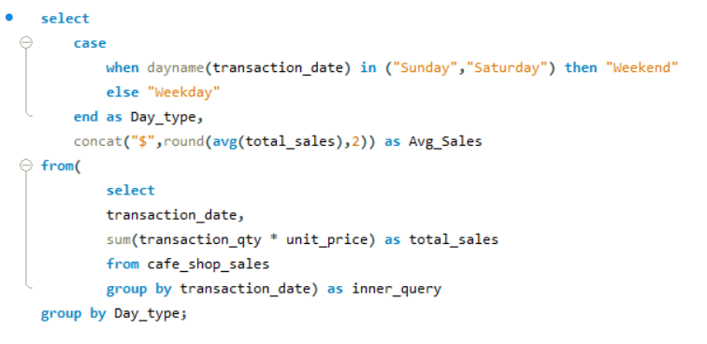
- The answer is NO, as we can clearly see on an average weekend maybe behind in sales from Weekdays but the difference is not major:
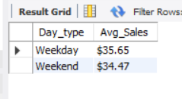
- Making some Data Manipulation, since we had anomalies in store locations.
- STORE LOCATION ANALYSIS MoM Trends:
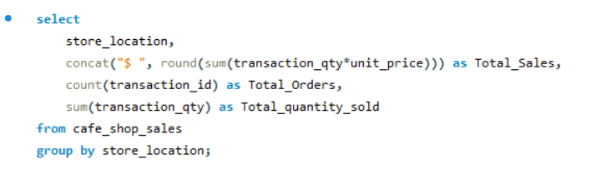
- Overall stats by different store location
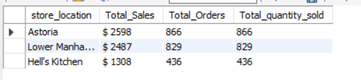
- MoM trendline in tabular format:
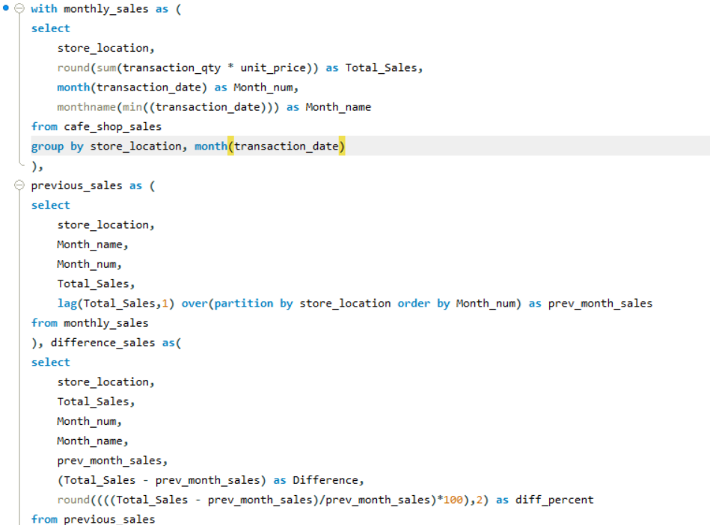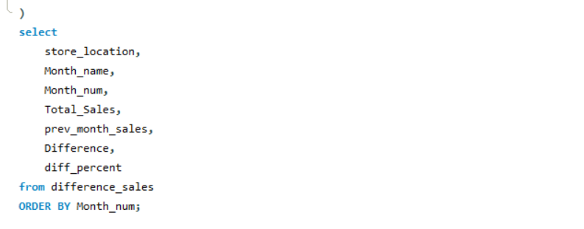
- Result was:

